CloudTrail & Cloudwatch:-

- Enable CloudTrail monitoring and store the events in S3 and CloudWatch log events.
First create a bucket by enabling “Block public Access”
Add bucket policy to allow cloud trail:
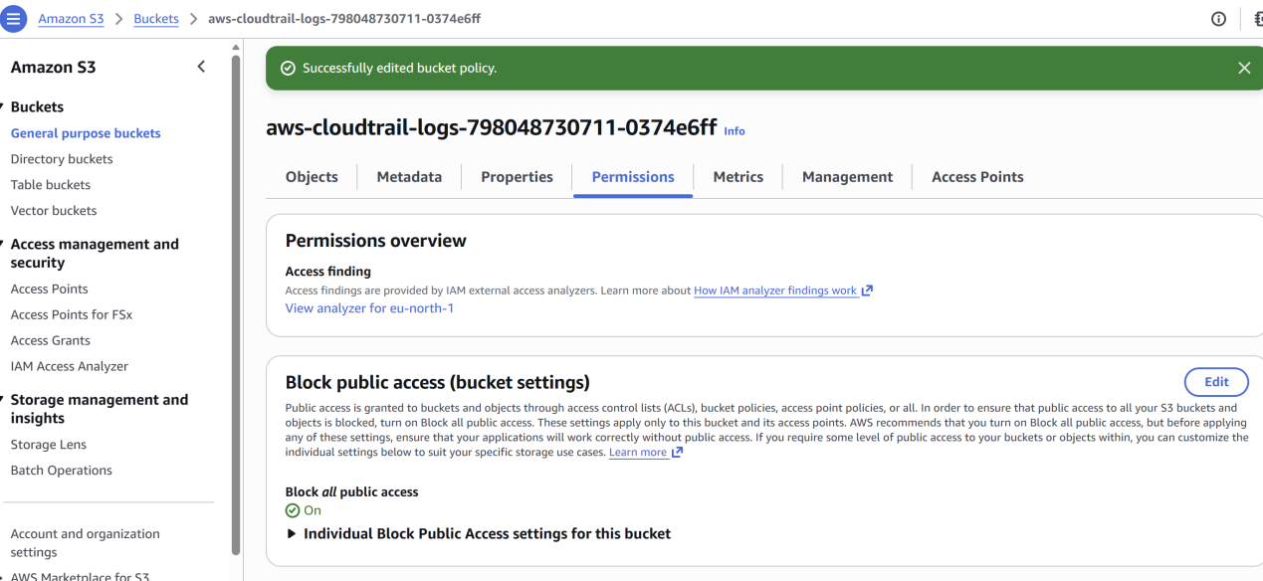

Go to Cloudwatch and create a log group…

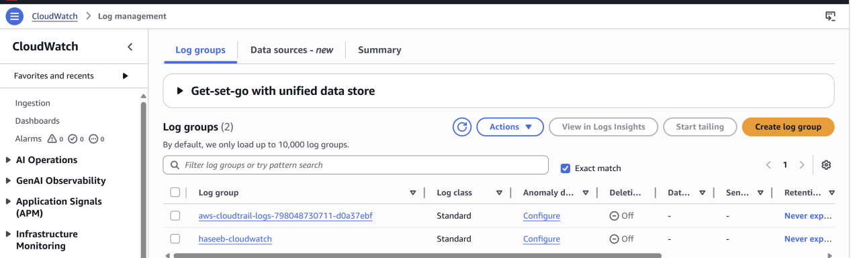

Create an IAM Role..

Create a KMS Key ..

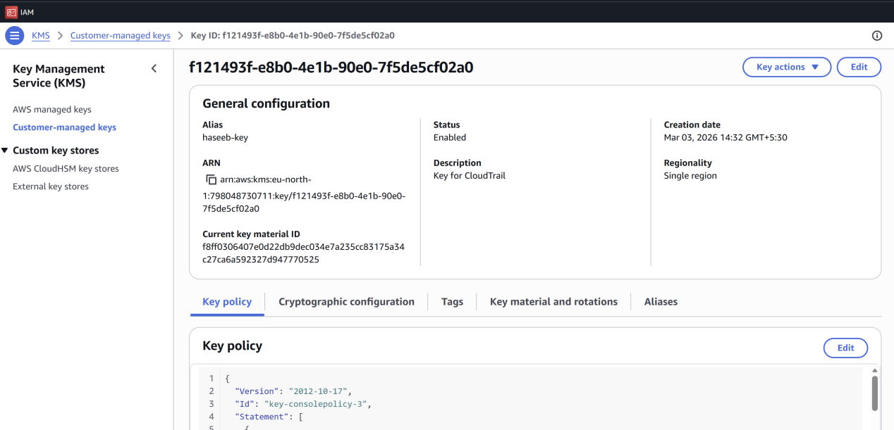

Go to Cloud Trail and create a new trail..

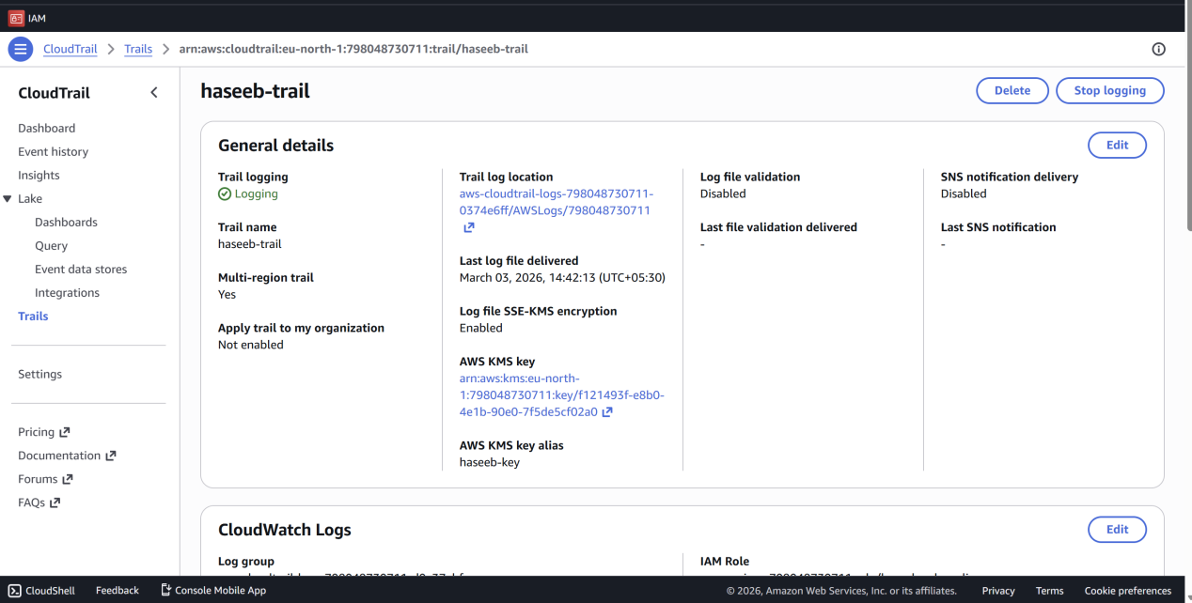

Verify now to check if its working…
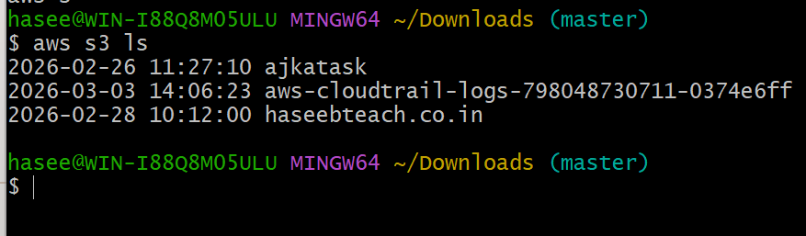

- Enable SNS for CloudTrail to send alerts via email.
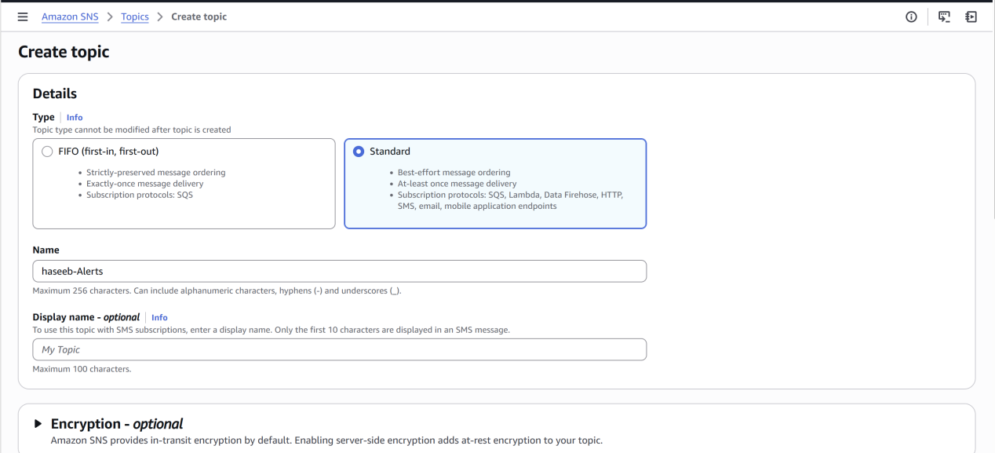
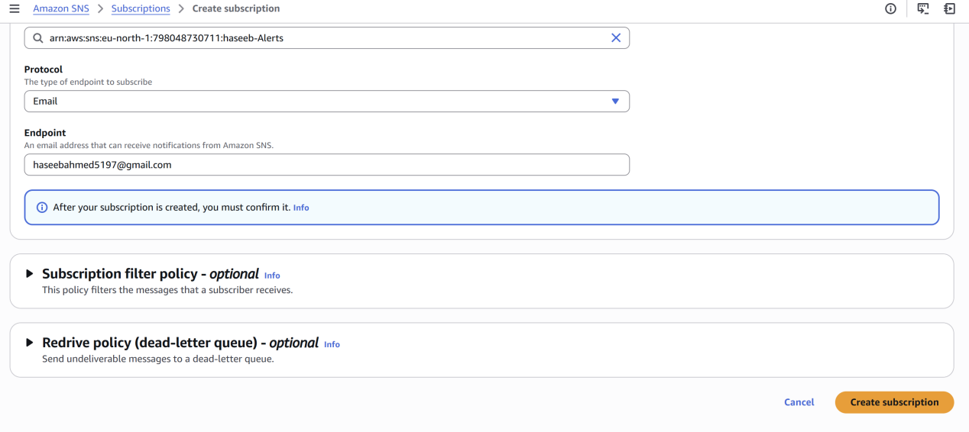
Confirm the request from the email..
Come to cloud trail --> edit and select existing SNS topic, you should see the created name..
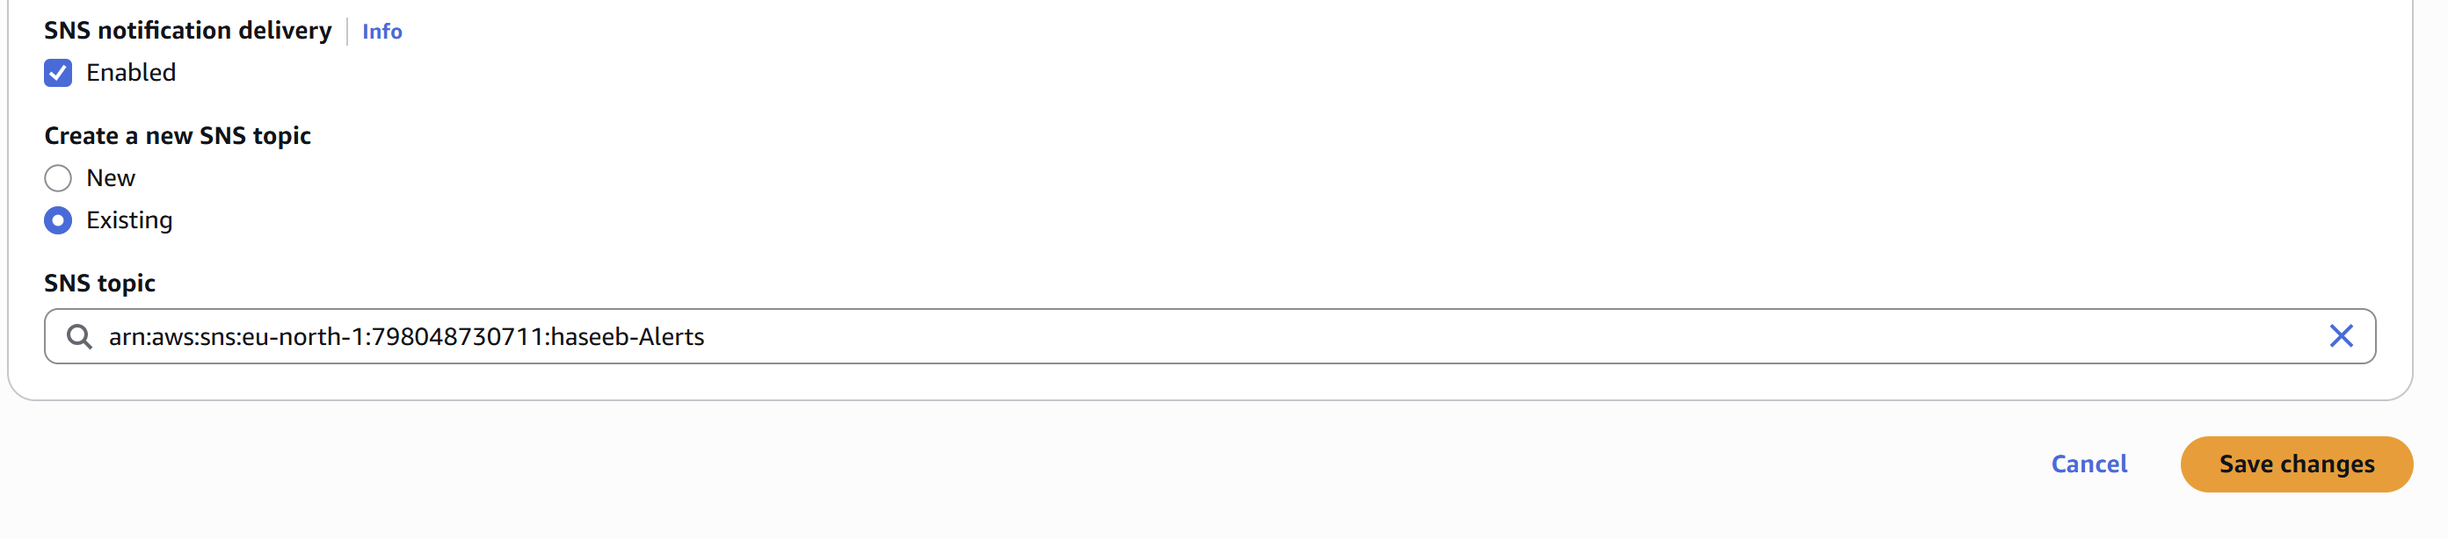
- Configure CloudWatch monitoring and record the CPU utilization and other metrics of EC2.

Create an EC2 instance and Actions > monitoring >
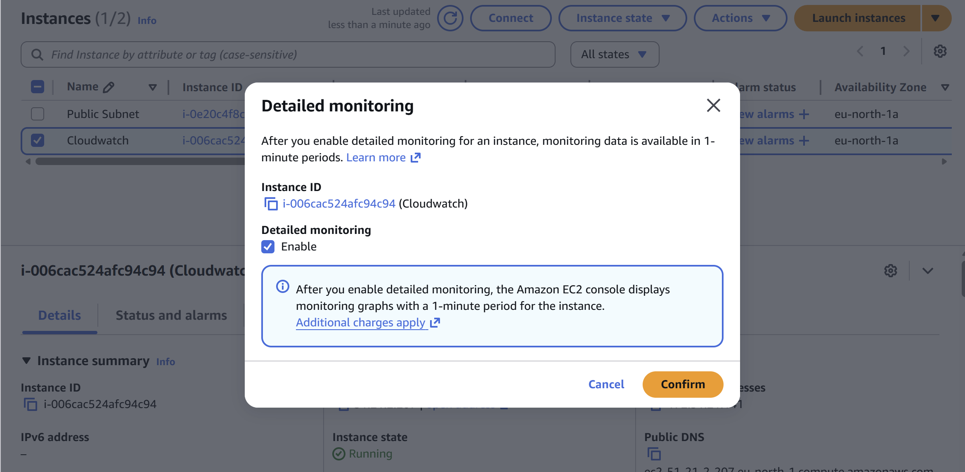

Ec2 instance > Metrics> (select your instance metrics as networkin, network out, cpu utilisation)>
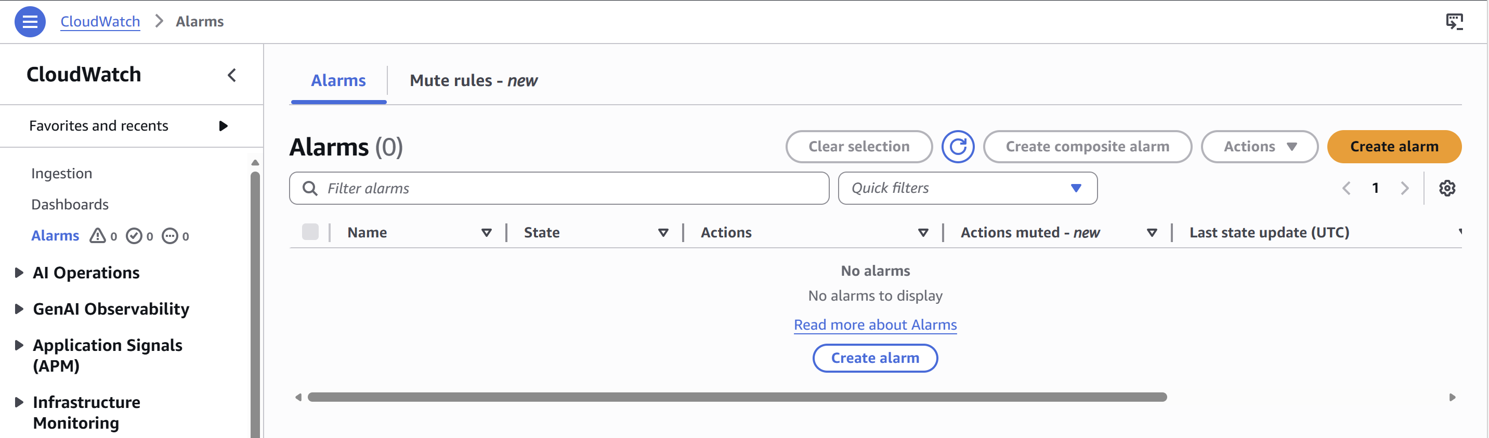
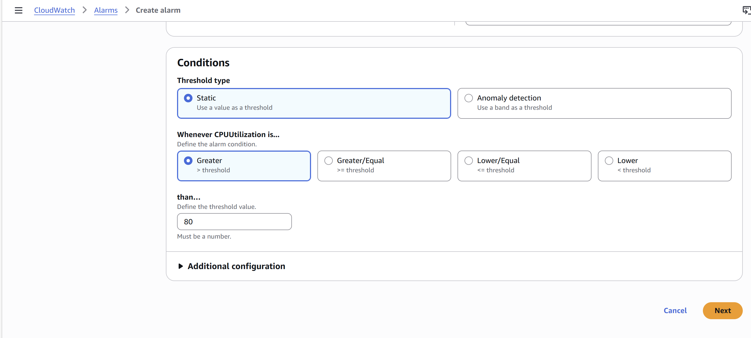

Check in the EC2 instance by doing the fake load test..
Sudo yum install stress -y
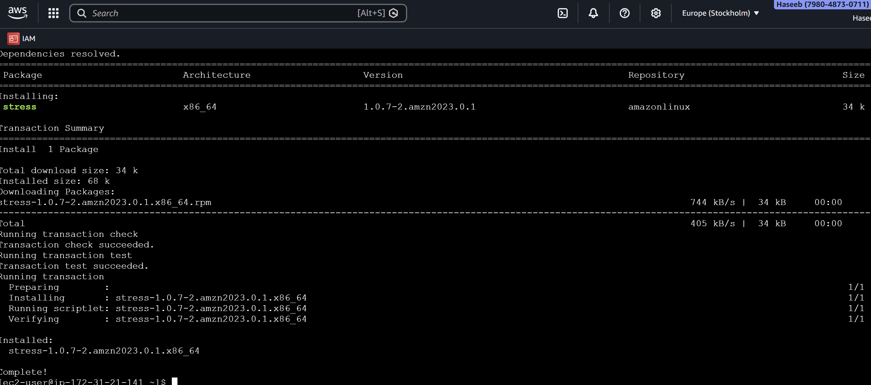
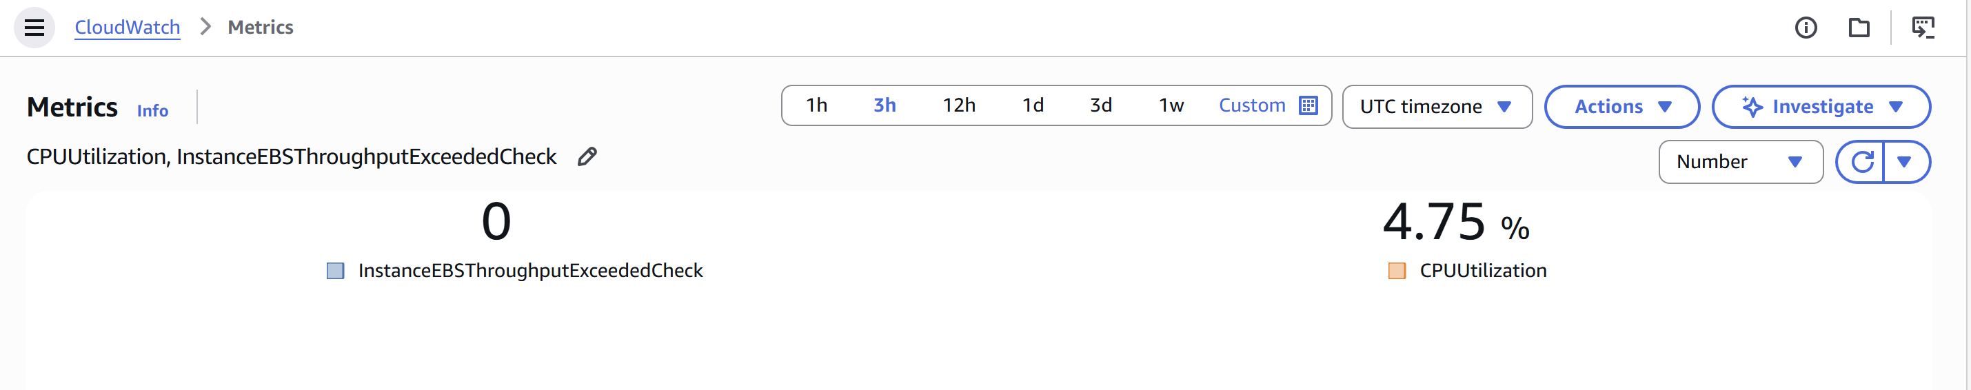

- Create one alarm to send an alert to email if the CPU utilization is more than 70 percent.

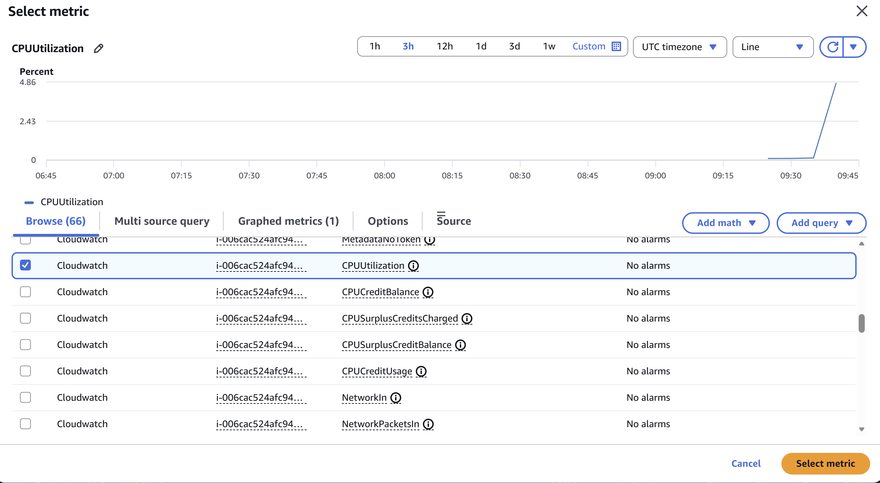
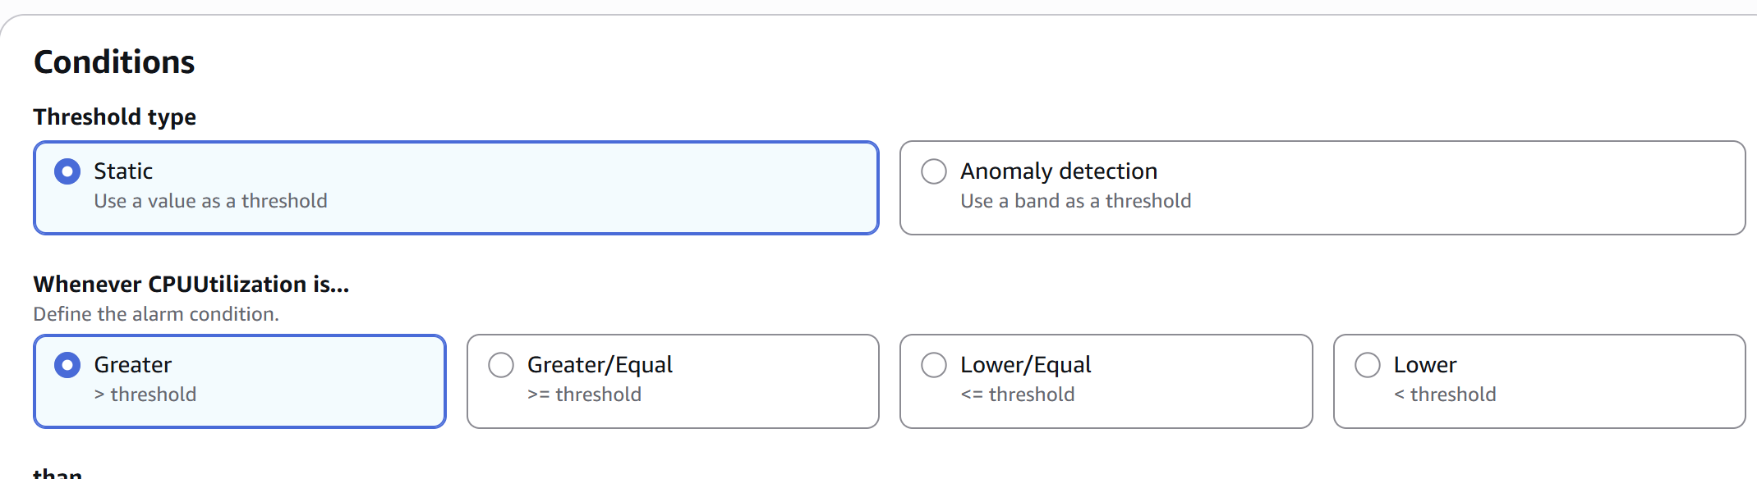
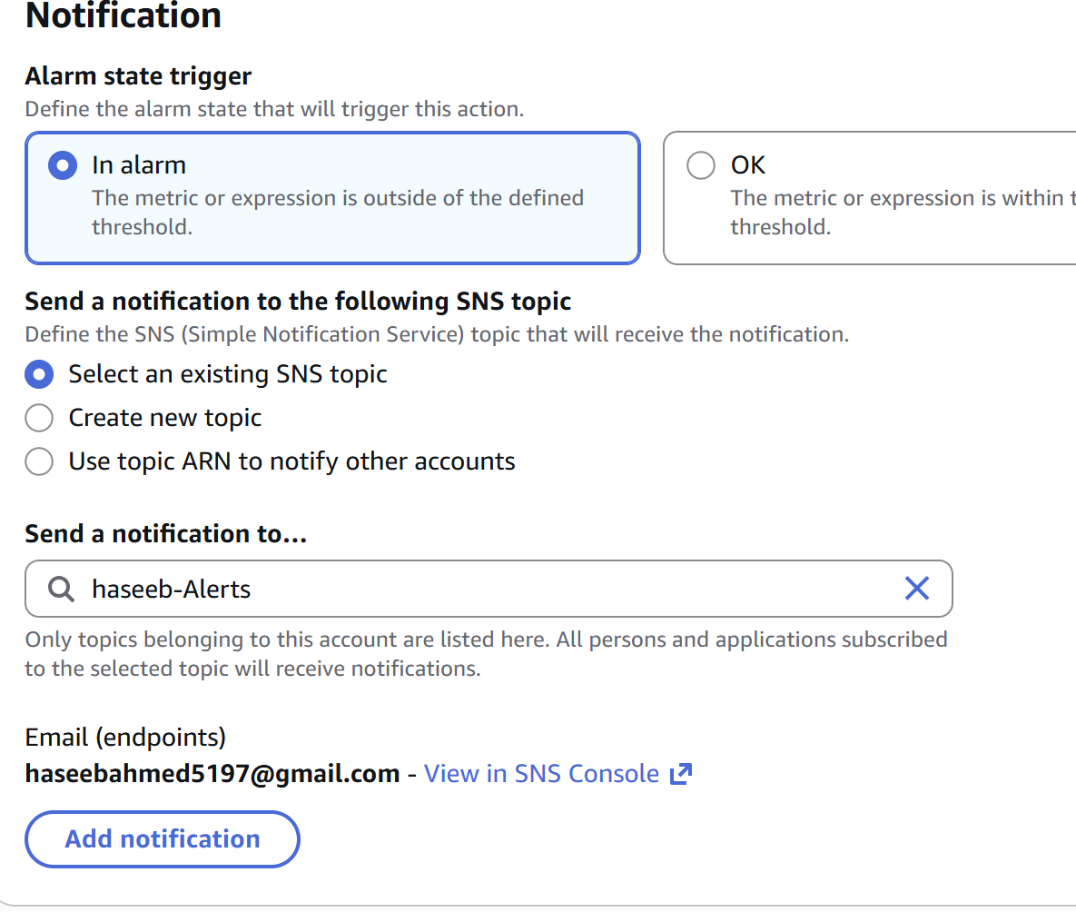
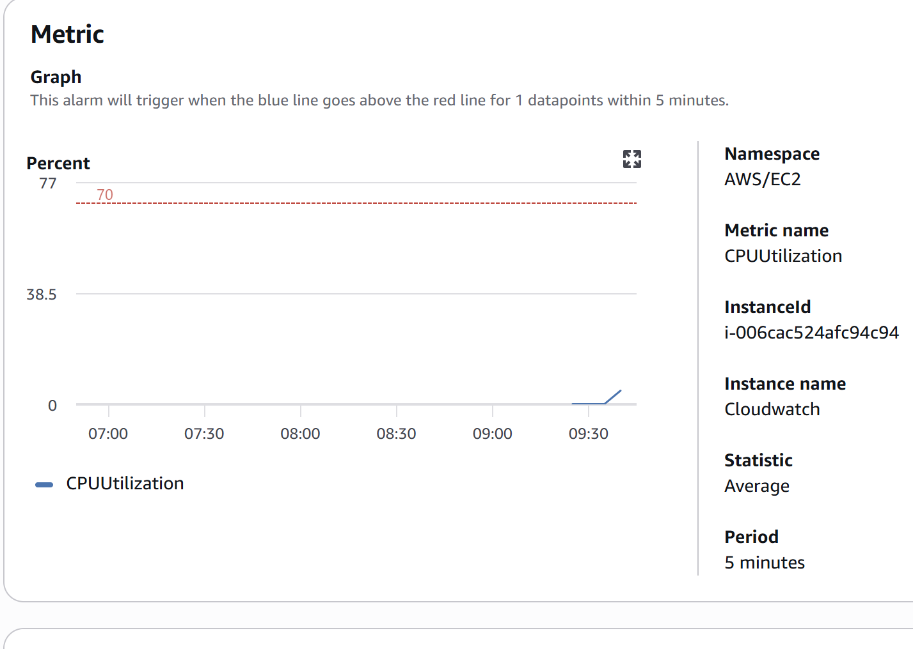
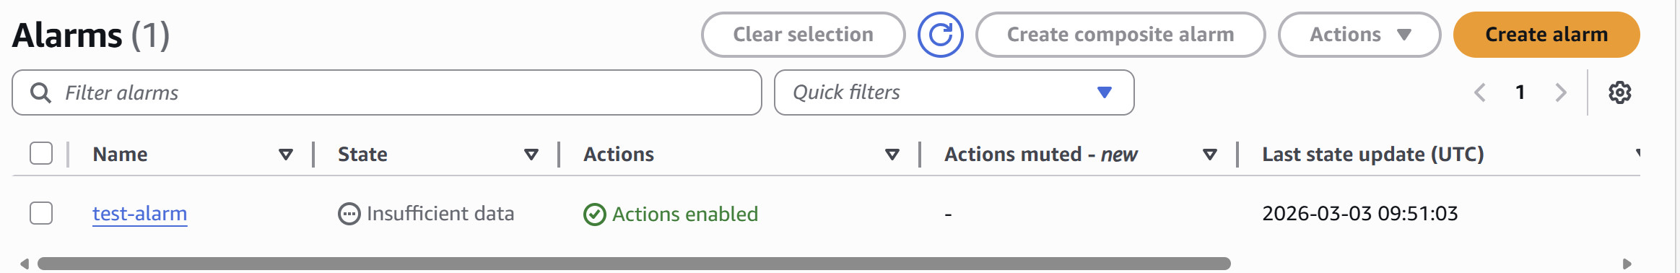

- Create a Dashboard and monitor the Tomcat service whether it is running or not and send the alert.
Sudo yum install amazon-cloudwatch-agent -y
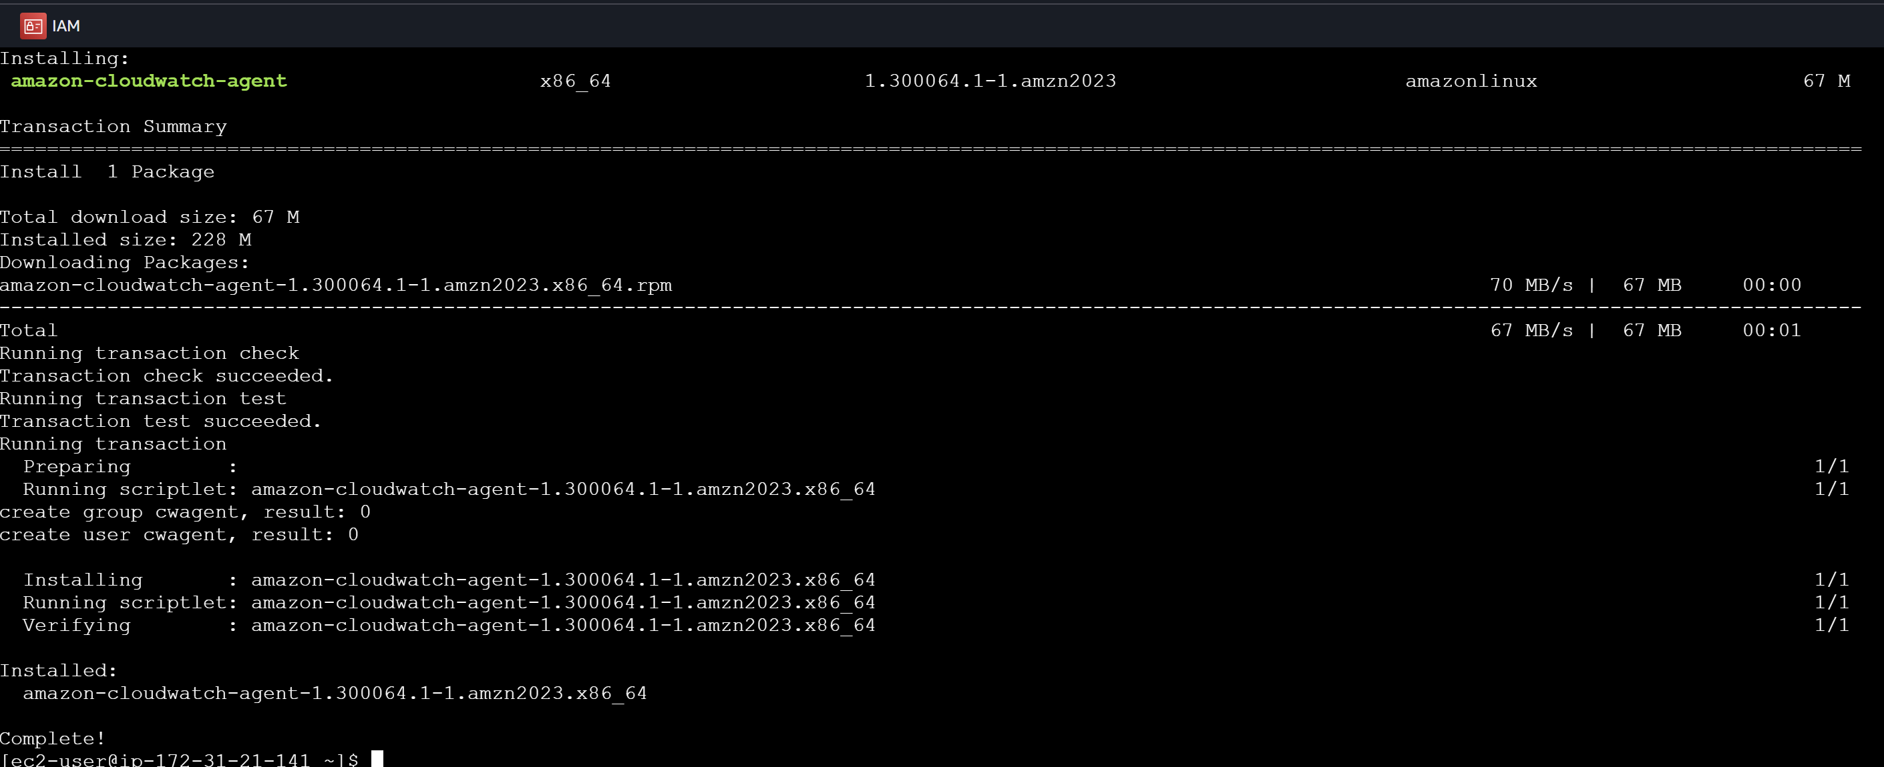
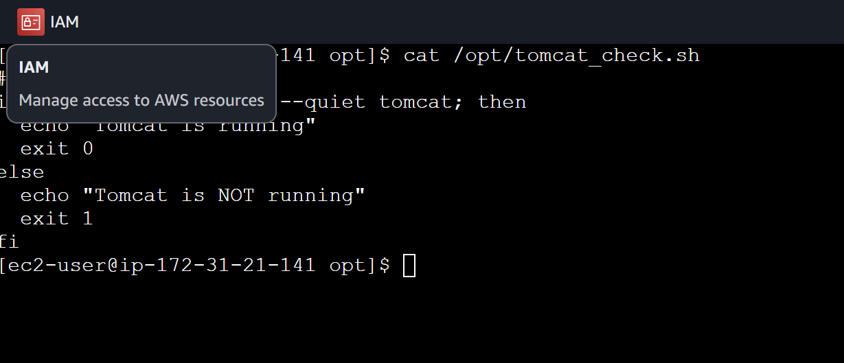
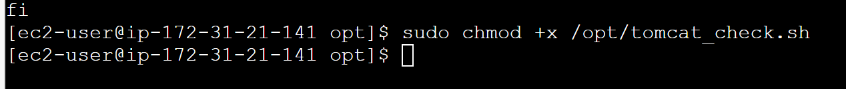
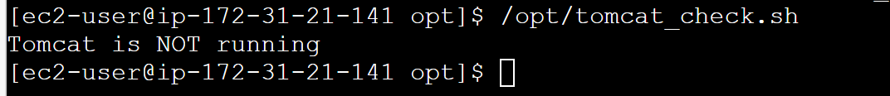

- Create a Dashboard and monitor the Nginx service to send the alert if Nginx is not running.
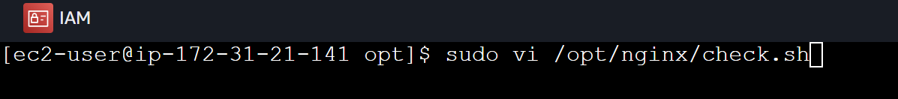
Need to modify the IAM role…
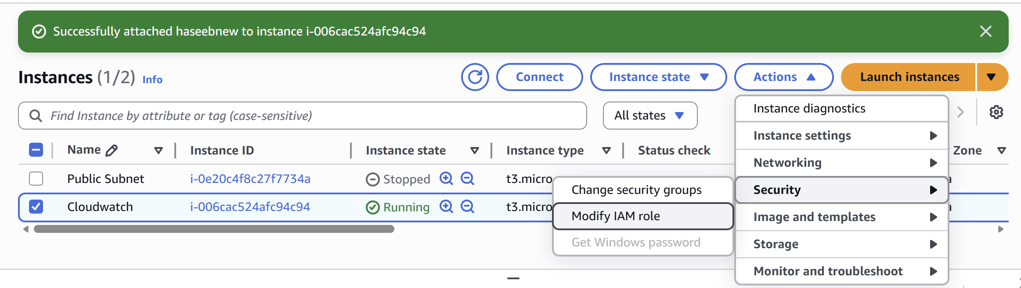

Should see this…
